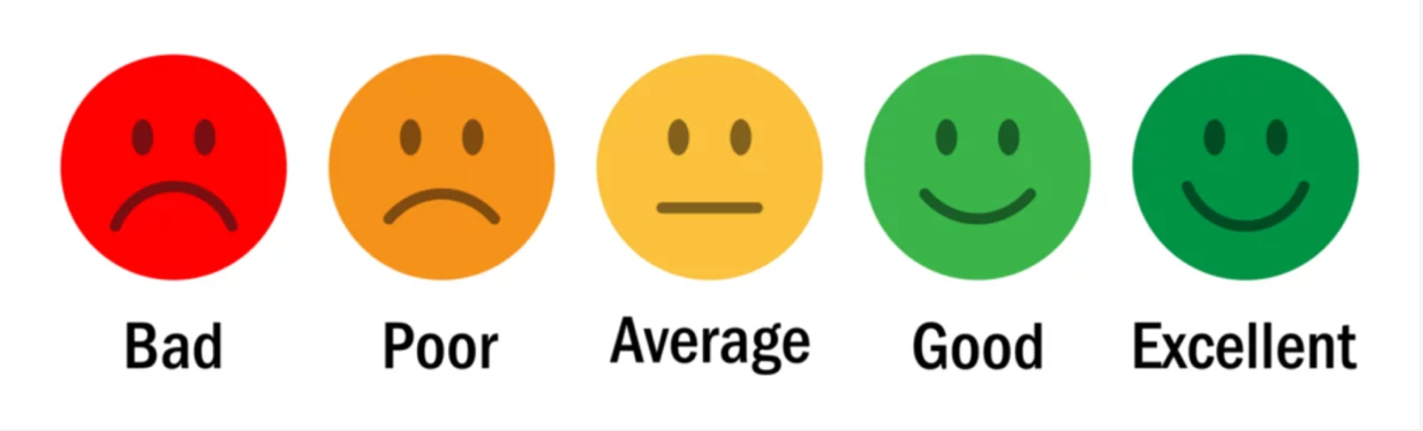

Survey Request Verbiage:

Dear (Insert Patient’s Name):

To provide the best possible service to meet your dental care needs, we would appreciate feedback on your experience in our dental office.

We would appreciate it if you would take a moment to complete this brief survey about your most recent visit to our practice.

Thank you for your valuable input.

Sincerely,

(Dentist Name)
(Dental Office)

Survey Reminder To Increase Patient Response Rate:
Please Note: This email should be sent no sooner than 3 days after the initial message.

Dear (Insert Patient’s Name):

We recently sent you a link to an e-survey asking for your opinions about your most recent visit to our dental practice.

If you have already completed the survey, please know that we appreciate your feedback. If you have not had the opportunity to complete the e-survey, we ask that you take a few moments to let us know your opinions.

Thank you for your valuable input.

Sincerely,

(Dentist Name)
(Dental Office)

1. What is your age?
The answer should be a single choice:
- Under 18
- 18-24
- 25-34
- 35-44
- 45-54
- 55-64
- 65 or older
2. What is your gender?
The answer should be a single choice:
- Male
- Female
3. How often do you visit the dentist?
The answer should be a single choice:
- Every 6 months
- Once a year
- Every 2-3 years
- Only when I have a problem
4. How easy was it to book your appointment?
The answer should be a single choice:
- Very easy
- Somewhat easy
- Neutral
- Somewhat difficult
- Very difficult
5. Did the receptionist greet you in a friendly manner when you arrived for your appointment?
The answer should be a single choice:
- Yes, very friendly
- Yes, somewhat friendly
- Neutral
- No, somewhat unfriendly
- No, very unfriendly
6. Was the clinic clean and well-maintained?
The answer should be a single choice:
- Yes, very clean and well-maintained
- Yes, somewhat clean and well-maintained
- Neutral
- No, somewhat unclean and poorly maintained
- No, very unclean and poorly maintained
7. Was the waiting area comfortable and pleasant?
The answer should be a single choice:
- Yes, very comfortable and pleasant
- Yes, somewhat comfortable and pleasant
- Neutral
- No, somewhat uncomfortable and unpleasant
- No, very uncomfortable and unpleasant
8. How satisfied were you with the level of care you received from your dentist?
The answer should be a single choice:
- Very satisfied
- Somewhat satisfied
- Neutral
- Somewhat dissatisfied
- Very dissatisfied
9. Did the dentist explain the procedures to you in a clear and understandable manner?
The answer should be a single choice:
- Yes, very clearly and understandably
- Yes, somewhat clearly and understandably
- Neutral
- No, somewhat unclearly and not understandably
- No, very unclearly and not understandably

10. How satisfied were you with the results of your dental treatment?
The answer should be a single choice:
- Very satisfied
- Somewhat satisfied
- Neutral
- Somewhat dissatisfied
- Very dissatisfied
11. Did the dentist or dental hygienist give you tips on how to better care for your teeth and gums?
The answer should be a single choice:
- Yes, very informative and helpful
- Yes, somewhat informative and helpful
- Neutral
- No, somewhat uninformative and unhelpful
- No, very uninformative and unhelpful
12. How likely are you to recommend our clinic to family or friends?
The answer should be a single choice:
- Very likely
- Somewhat likely
- Neutral
- Somewhat unlikely
- Very unlikely
13. Overall, how satisfied are you with your experience at our clinic?
The answer should be a single choice:
- Very satisfied
- Somewhat satisfied
- Neutral
- Somewhat dissatisfied
- Very dissatisfied

Dear (Insert Patient’s Name):

Your feedback is valued, and you are appreciated for taking a few moments to share thoughts on your recent experience at our dental practice. Your responses will help improve our services and ensure a positive experience for all patients.

Thank you for your valuable input.

Sincerely,

(Dentist Name)
(Dental Office)

Please choose the face that best represents your feeling for each question:

What is your age?
The answer should be a single choice:
- Under 18
- 18-24
- 25-34
- 35-44
- 45-54
- 55-64
- 65 or older
What is your gender?
The answer should be a single choice:
- Male
- Female

How often do you visit the dentist?
The answer should be a single choice:
- Every 6 months
- Once a year
- Every 2-3 years
- Only when I have a problem

1. Ease of scheduling your appointment:
- 😀 Very Happy (Easy)
- 😊 Happy
- 😐 Neutral
- 😞 Unhappy
- 😠 Very Unhappy (Difficult)

2. Length of time you waited before being seen:
- 😀 Very Happy (No wait)
- 😊 Happy
- 😐 Neutral
- 😞 Unhappy
- 😠 Very Unhappy (Long wait)

3. Friendliness and professionalism of our reception staff:
- 😀 Very Happy
- 😊 Happy
- 😐 Neutral
- 😞 Unhappy
- 😠 Very Unhappy

4. Cleanliness and comfort of our waiting area:
- 😀 Very Happy
- 😊 Happy
- 😐 Neutral
- 😞 Unhappy
- 😠 Very Unhappy

- Friendliness and professionalism of your dental hygienist/assistant:
- 😀 Very Happy
- 😊 Happy
- 😐 Neutral
- 😞 Unhappy
- 😠 Very Unhappy

- How well your dentist/hygienist listened to your concerns:
- 😀 Very Happy (Very Well)
- 😊 Happy (Well)
- 😐 Neutral
- 😞 Unhappy (Poorly)
- 😠 Very Unhappy (Not at all)

- Clarity of explanations about your treatment and procedures:
- 😀 Very Happy (Very Clear)
- 😊 Happy (Clear)
- 😐 Neutral
- 😞 Unhappy (Unclear)
- 😠 Very Unhappy (Very Unclear)

- Comfort level during your treatment:
- 😀 Very Happy (Very Comfortable)
- 😊 Happy (Comfortable)
- 😐 Neutral
- 😞 Unhappy (Uncomfortable)
- 😠 Very Unhappy (Very Uncomfortable)

9. Overall satisfaction with your recent visit:
- 😀 Very Happy
- 😊 Happy
- 😐 Neutral
- 😞 Unhappy
- 😠 Very Unhappy

Comments: ( 200 Chars) Text Box.

